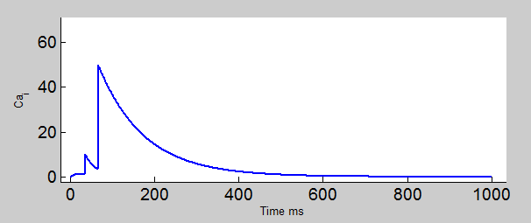

there seems to be a scaling issue… which may be due to the value of a2 and a3??

* This was solved when I decided to calculate the values of a2 and a3 instead of using the “predicted” values

